**Cutscenes in platformer games: why and how?**Research done by Dennis Butijn

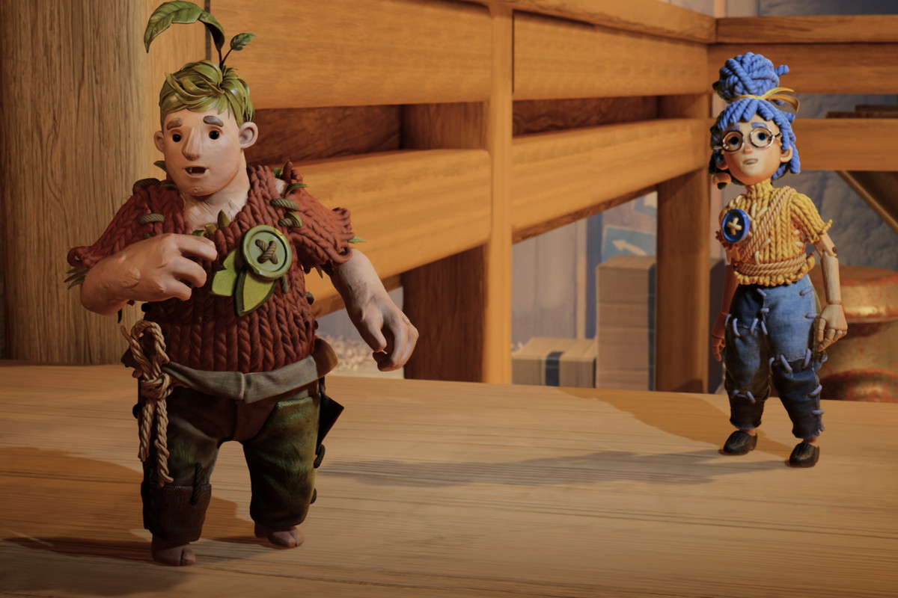

*Note: as Word doesn’t support videos, CTRL + Click on the cutscene thumbnails to be redirected to the YouTube link.*

## Introduction

Expanding on the concept of Mushroom boy, we want to add cutscenes as introduction to the game, visualize a change of climate and on pick-up of a key collectible which is the main reward system of the game.

With this document, I want to research how similar platformer games apply cutscenes, figure out when to use cutscenes and what different methods there are to implement cutscenes into our project.

## Research question and sub-questions

When and why are cutscenes being used in platformer games?

* When are cutscenes being used in other platformer games?
* How to avoid a cutscene breaking the flow of the game?
* What kind of camera movement systems are being used in other platformer games?
* What kind of ways are there to integrate cutscenes in Unreal engine?

## Data

First things first, it’s good to consider what a “cutscene” actually is. A cutscene is a sequence in a game in which a short video is being displayed, often to support the level’s story or to evoke a certain emotion from the player (often to hype up the game). An important aspect is that **the player has no interaction with the game anymore**. A cutscene interrupts the gameplay and therefore can be seen as frustrating when not being used well. Let’s take a look at the location of cutscenes in modern platformer game’s levels.

**Researched games:**

* Crash bandicoot 4: It’s About Time
* Super Mario Galaxy
* Super Mario Odyssey
* It Takes Two

**When are cutscenes being used in platformer games?**

* **Introduction**: In all researched games, the game started with a cutscene. With the duration of 2-3 minutes, these cutscenes are on average longer than other (non-intro) cutscenes. These cutscenes are used to explain the lore of the game: What is the game about? Why does the player have to traverse through the level? The main goal of the game is usually explained in introduction cutscenes. It’s important to tell the story of the game and the motives of the character to the player in the first 5-10 minutes of the game. Not doing this and the player gets confused and loses interest in the game itself.  
  *Introduction video duration:*
  + *Crash Bandicoot 4: It’s About Time:* 1 minute and 46 seconds
  + *Super Mario Galaxy*: 1:33 + 1:58 = 3 minutes and 31 seconds (piece of gameplay in between, in theory 2 intro cutscenes)
  + *Super Mario Odyssey*: 1 minute and 36 seconds
  + *It Takes Two*: 6 minutes and 46 seconds

](https://youtu.be/jZqsvBS09r8)[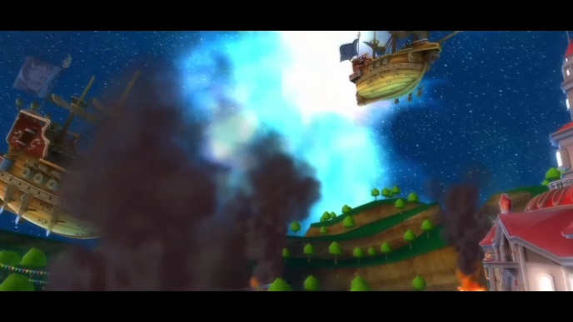](https://youtu.be/jkkyQA56w10)

Introduction cutscene in Crash Bandicoot 4

Introduction cutscene in Super Mario Galaxy

* **Begin/end of a level**: In all researched games, cutscenes are often being used at the start or end of a level. These are used to introduce the level, elaborate upon the story, or give the player a moment of rest (end of a level). Placing a cutscene at the end of a “difficult” level will also purpose as a reward to the player. It shows progression to the player and lets them know that they’ve completed the level or sequence.

](https://youtu.be/DCkU9f09yEI)

Cutscene after level in Crash Bandicoot 4: elaborating upon the story of the game

* **In the middle of a level, after a parkour part**: In my researched games, the games that used a cutscene in the middle of a level were: It Takes Two and Crash Bandicoot. It is a risky moment to implement cutscenes as it has a chance of killing the game’s flow. Super Mario Odyssey rewards the player with a small cutscene of 4 seconds whenever the main collectible (moon) is picked up. These kind of cutscenes are used to visualize a sudden change in the level (player learns a new mechanic, a new enemy spawns in, the environment of the level changes), or reward the player with the progression they are making (picking up a moon in Mario Odyssey).

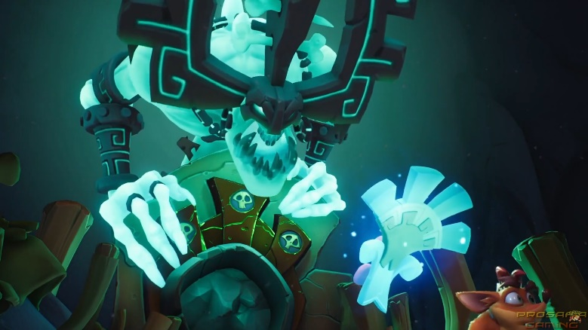

Cutscene used in the middle of a level in Crash Bandicoot 4: sudden change in level

**Why are cutscenes being used in platformer games?**

* *Scene and mood setting*: A cutscene can often be used to set the mood or tone of a scene. This sets a feel for the game. A good example are horror games which usually use dark cinematic with tight environments.
* *Reward*: As previously mentioned, a cutscene can feel like a reward. Seeing a cutscene as a player means progression. Especially after a difficult sequence of gameplay a cutscene can feel rewarding.
* *Introduction to the story*: Frequently, a cutscene is played right at the start of the game, to introduce the story to the player. For the player it’s important to know what the story is, and what the character’s morals are. These are often explained through a cutscene right at the start.
* *Show effects of character’s actions*: A cutscene can be used to make the player show not just what influence the player’s actions had on the character, but also on the in-game world. Has the player made a wrong decision and destroyed the world? Or maybe the player has collected all collectibles and a certain event happens.
* *Pacing*: Cutscenes alone can make the pacing of the game feel much different. By using a longer cutscene the player will get more rest and the game starts to feel slower after the cutscene (for example a moment of dialogue), whereas short cutscenes can bring up the pace (for example, an enemy wakes up).

[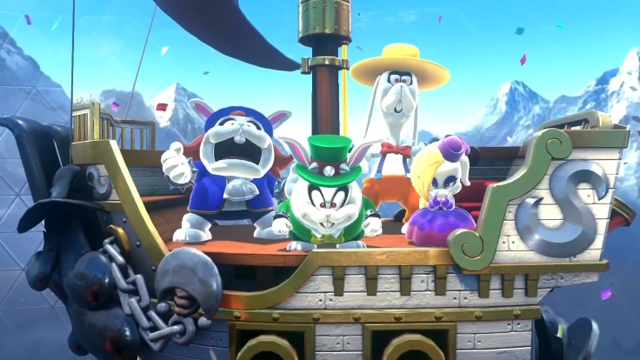](https://youtu.be/ESChW4RiQns)

Cutscene in Super Mario Odyssey announcing a boss fight. This quick cutscene prepares the player for what's coming up next

Cutscene in Super Mario Galaxy used to reward the player and show progression

As a designer it’s incredibly important to understand how cutscenes work. Using them wrong will result in the player fading out of the game flow and starts getting annoyed. Misplaced cutscenes, cutscenes that don’t make sense with the gameplay, too many cutscenes. These are issues to consider when deciding to create cutscenes in a level.

**Camera movement:**

* Usually 3 or 4 different camera angles used which are all being played for 2-5 seconds until going to another camera angle. A camera angle can be used several times in 1 shot.
* In It Takes Two, the camera changes position constantly to create a more dynamic camera feeling.
* In Crash Bandicoot 4, the camera is in 1 place with regular “quick transitions” to make sure the point of focus stays correct in the camera view when it’s moving. The camera follows the point of focus in this case
* The Super Mario series does close to the same as Crash Bandicoot’s camera movement: one position and quick transitions when the point of focus moves.

[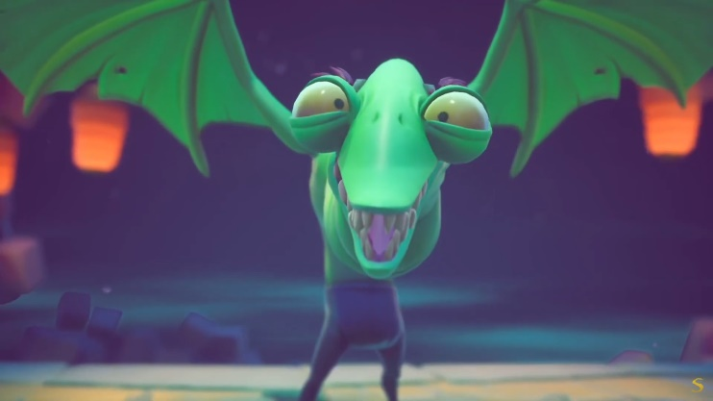](https://youtu.be/SJr8vMxBfFE)

Camera in It Takes Two: constantly moving

Camera in Crash Bandicoot 4: moments of camera not moving followed by quick transition to follow point of focus

**2 ways of integrating cutscenes in Unreal:**

*Using the Unreal* sequencer: To create cutscenes in an existing level in unreal, you can use the sequencer functionality that’s integrated in Unreal. By creating a new camera and importing that camera into the sequence, you can edit the location and rotation of the camera over time.

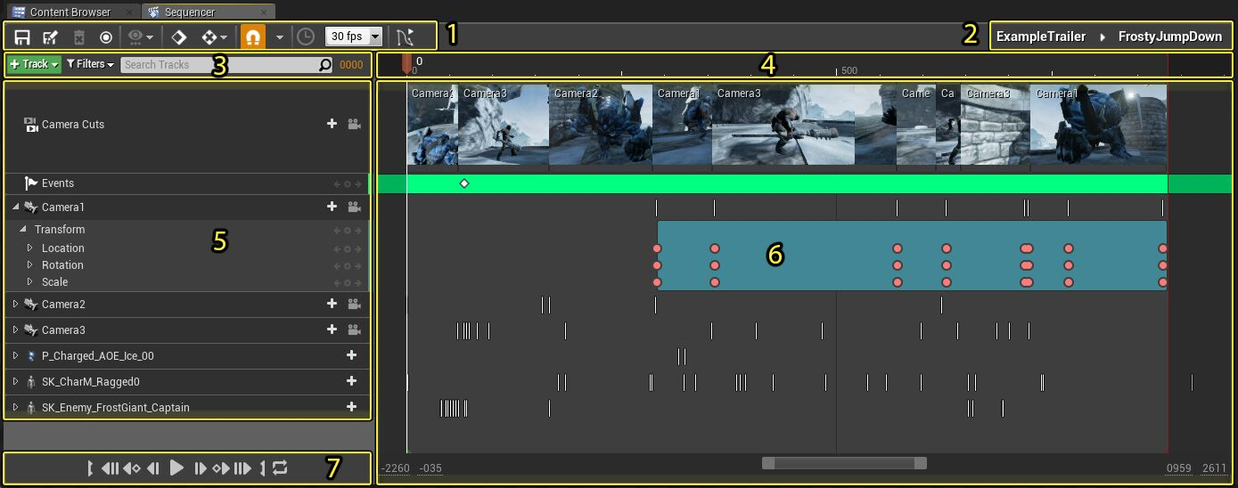This method makes sure that a smooth transition between gameplay and cutscene can be created. A downside, however, is that the cinematic gets rendered in real-time meaning that it does require performance from the GPU.

*Pre-rendered:* It’s possible to integrate a video file into Unreal. A cutscene can be animated beforehand in another software and used in the Unreal Engine. To do this, place the video in a media player. The texture that comes with creating the mediaplayer can be placed on a widget. When adding that widget to the viewport the video is playing full screen. This is a technique that I learned about last block and can be helpful this block.

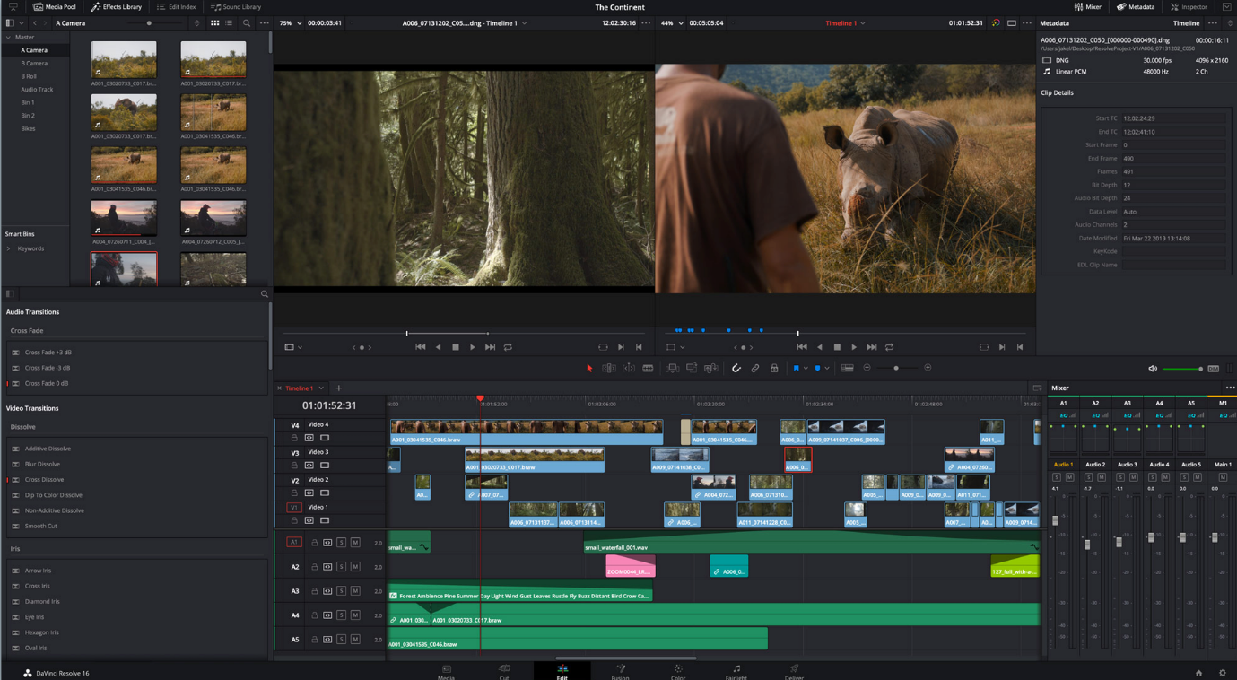The advantage here is that a sequence can be video-edited to own preference and that playing the video in-game doesn’t take GPU performance. The downside however is that it’s a lot of work to create these pre-rendered cinematics. Let alone learning a new software for animating the video and video-editing this to own preference.

**Choosing between the sequencer and pre-rendered cutscenes**  
For this project, we’re going with using the sequencer instead of pre-rendered cutscenes. Unreal makes it simple to create cinematics in real-time with the sequencer functionality. To create cutscenes, a designer would need to learn about the sequencer functionality in Unreal whereas pre-rendered cutscenes need to be made in another software which then requires learning that software. For the prototype we’re making, using the sequencer creates the fastest results.

## Other notes

* An animation sequence can be added as well to display an animation over time (character walking, running etc.). This is quite advanced for a beginner to sequencers so most likely this is going to be out of scope for this project.

## Conclusion

Cutscenes in platformer games are typically used to explain or elaborate upon the story. Cutscenes are often being played at the start of a game to introduce the story/character to the player.

Cutscenes are also often placed at the start/end of a level. This can create a sort of overlap, but more importantly, it can control the gameplay pace. A cutscene after a challenging level will feel as a reward and creates rest in the player’s head: the gameplay’s pace slows down. On the other side, using fast cutscenes grabs the player’s attention and increases the gameplay pace.

As a designer it’s vital to understand when to use cutscenes and when not to use cutscenes. You want to have the least interference in the player’s flow in the game. A misplaced cutscene could frustrate the player hence to be careful with placing cutscenes.

A cutscene in the middle of a level is a dangerous design decision to make. However, it’s being done in Crash Bandicoot all the time. The magic they us is that they keep the cutscene short, and the cutscene presented is valuable for the gameplay after the cutscene (like an enemy that has spawned).

To prevent the cutscene from becoming boring, cutscenes in the researched games use shots of 2-5 seconds. This means that there are multiple camera angles in place. There are two ways to make the cutscene feel more dynamic:

* Have the camera constantly moving.
* Follow the point of focus with quick camera transitions

There are 2 ways to integrate cutscenes into Unreal: using the built-in sequencer or pre-render. To create cutscenes in a fast way, we will be using the sequencer. They allow for rapid prototyping as they are being created in the editor and can easily be adjusted. However, pre-rendering cutscenes creates the opportunity to video-edit the cutscene to own favor, whereas the sequencer is limited on that regard.

## Take-aways

* An introduction cutscene will be made in Mushroom Boy to explain the story of the game (forest infected, Mushi needs to save the forest).
* We will use a cutscene for the start of a level: when entering a biome show a quick overview of the level. End the cutscene with the character entering this biome (sweating when entering the sun biome, feeling cold when entering the ice biome etc.).
* Using different camera angles for every cutscene, trying to adhere to the 2-5 second duration per shot.
* We’re using the sequencer built-in Unreal Engine, which makes iterations in cutscenes easily possible.

## Sources

* Sequencer for Linear Animation Workflows by Unreal Engine -
* How to display a video in a widget by Matt Aspland -   
  <https://youtu.be/qhiSl8i4jbQ>
* How to create a cinematic in the sequencer by Matt Aspland - <https://youtu.be/FOS9FMbUtq0>
* Full script of Crash Bandicoot 4’s cutscenes - <https://crashbandicoot.fandom.com/wiki/Crash_Bandicoot_4:_It%27s_About_Time_script>
* [Sequencer Training and World Setup for Cinematics from Unreal Engine Learning - https://learn.unrealengine.com/course/2436533/module/5380169?moduletoken=UHxxnDLPW8R5vChXbVqFk~bMBfz2mCCsCluMP2hcfi8DseM4qCRpj4ULvwyDORh5&LPId=0](https://learn.unrealengine.com/course/2436533/module/5380169?moduletoken=UHxxnDLPW8R5vChXbVqFk~bMBfz2mCCsCluMP2hcfi8DseM4qCRpj4ULvwyDORh5&LPId=0)
* How to improve game design with cutscenes by Gamasutra - <https://www.gamasutra.com/view/feature/3001/better_game_design_through_.php?print=1>
* Super Mario Galaxy walkthrough  
  <https://youtu.be/zc7Ob4ACTQM>
* Super Mario Odyssey walkthrough  
  <https://youtu.be/ZrruckoSmBU>
* Crash Bandicoot 4 walkthrough  
  <https://youtu.be/KEFpXuZaszY>
* It Takes Two walkthrough  
  <https://youtu.be/VTnsTYPy-F8>
* Unreal Engine forum question: using pre-rendered or real-time cutscenes?  
  <https://forums.unrealengine.com/t/pre-rendered-or-realtime-cutscenes-which-is-better/443229>